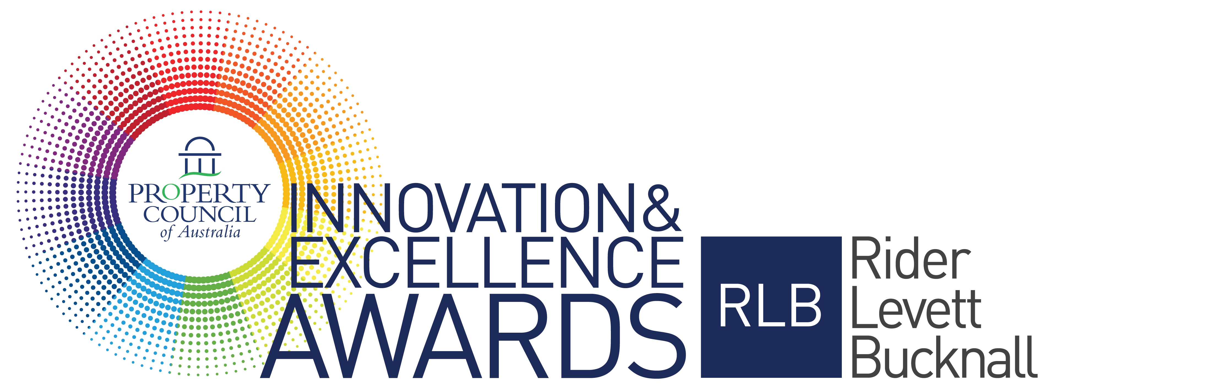

2021 Award Criteria & Questions

Suburban Land Agency Award for Best Affordable Housing Development

Sponsored by

Award Criteria

This award category seeks to award organisations that are committed to meeting an ever-increasing market demand for affordable housing.

The category is focussed on home ownership and is open to the private, community and government sectors. Applicants will need to ensure that all subsidies from the government are disclosed to allow like-for-like evaluation.

This award aims to recognise and publicly reward the ‘value for money’ in a new or refurbished affordable housing development.

Eligible entrants will be developments or refurbishments that have been completed in the previous five
years and have been operating for at least one year as at 31 December 2020.

Also, where the development is multi staged the entrant may nominate a completed stage and will be awarded on the basis of the completed stage only. The entrant may also enter further stages as they are completed in future years but will only be recognised for those nominated stages not previous ones.

The award is open to members of the Property Council of Australia only. Innovation in your responses should be clearly expressed.

All finalist projects for the National Awards will automatically be entered into their State Development of the Year. This award is presented in each state at an event prior to the National Awards Gala Dinner.

The State Development of the Year is determined by the National Awards judging panel and is awarded to the highest scored development in that state. An invitation will be issued to all finalists early in 2021 with details of their State Development of the Year event.

Nomination Form Questions (final entries must be submitted using the online nomination form)

NOMINATOR / CONTACT PERSON
Name
Position
Company
Mailing Address
Contact Number (Day)
Email
Mobile

DEVELOPMENT DETAILS
Name of Development
Address of development
Development type
Completion of development/refurbishment
Development size (NLA sqm)

OWNER DETAILS
Name
Position
Company
Mailing Address
Email
Phone Number (Day)

PROJECT TEAM
Developer
Architect
Planner
Quantity Surveyor
Builder
Consultants
Financier
Other

AWARD CEREMONY DETAILS
The winners will be presented at the Innovation & Excellence Awards Gala Dinner in Sydney on Friday, 13 August 2021. Should you be successful in winning this award, who will be receiving the award at the event?
Name
Position
Company
Mobile
Email

PROJECT SYNOPSIS
To assist judges in assessing your entry against the judging criteria, please provide a project synopsis of no more than 300 words.

MARKETING SYNOPSIS
To assist the organiser in promoting your entry within marketing material, please provide a summary about your entry of no more than 50 words.
DEVELOPMENT DETAILS UPON COMPLETION
Total Project Costs - $
Development Margin (%)
Development Profit - $
Project IRR (%)
Date of Completion
Current Valuation as supported by independent valuation - $
Median Rent and/or Market Price for Comparable Dwelling Type in the Location - $

ATTACHMENTS
Please upload a maximum of 6 images (minimum of 4 images is mandatory). Images are to be in a jpg format and high resolution (300dpi) and a maximum file size of 5MB each.

Judging Criteria

PREQUALIFYING CRITERIA

ECONOMIC AND FINANCIAL FACTORS – 35% WEIGHTING (Limit 800 words)

Detail how the development demonstrates the opportunity for people on low to moderate incomes to afford home ownership on both an initial cost and longer-term operating basis. Judges will look at the positioning of the project against the median price for a particular location and/or product.

SUPPORT CRITERIA

PROJECT VISION AND INNOVATION – 15% WEIGHTING (Limit 800 words)

Describe how the development displays innovation in the project concept and in overcoming site or development complexities. This should be described as a point of difference.

CORPORATE SOCIAL RESPONSIBLITY – 15% WEIGHTING (Limit 800 words)

Describe the projects approach to supporting people to maintain connection with their community and neighbourhood, avoid social isolation, increased broader economic benefit (such as ageing-in-place) and maintaining home ownership over time.

Applicants may wish to address the projects specific demographic or sectoral responses such as accessibility, adaptability, health care or provision of other facilities for those with other abilities such as sensory impairment etc. with an emphasis on high amenity experience for occupants.

QUALITY OF DESIGN AND FINISH – 15% WEIGHTING (Limit 800 words)

Detail and provide examples on how the development exhibits a high quality of architectural design; represents value for money and is compatible with surrounding land uses and contributes to the success of housing affordability (e.g. site constraints, unique design solutions, and project cost constraints). Include supporting pictures.

RESIDENT SATISFACTION – 10% WEIGHTING (Limit 800 words)

Describe, using testimonials from a variety of stakeholders, the extent to which the development has a proven high satisfaction level of all users.

INDUSTRY PERCEPTION – 10% WEIGHTING (Limit 800 words)

Describe, using testimonials from a variety of stakeholders, the extent to which the development is considered a success by the property marketplace or a particular affordability sector.

Conditions of Entry

- Entry in the Property Council of Australia/Rider Levett Bucknall Innovation & Excellence Awards costs $1,260 (including GST) per nomination.
- Nominated companies must be a Property Council of Australia member
- We welcome both self-nomination and third party nominations.
- Before you submit your nomination, ensure you have permission from the owner, your client or your contractor to do so.
- All entries must be submitted via the online Nomination form.
- Entries must stick to the word limit on the online nomination form. Nominees are reminded that judges will not consider formatting or presentation of entries.
- Nominees must include 4-6 images to support their submission. Other material relevant to support the application may also be uploaded as an Appendix.
- All nominees should be prepared to attend a site inspection with a judge, should it be deemed necessary.
- All nominations and contents will remain the property of the Property Council of Australia.
- Please note entries are exclusive to the Property Council of Australia Innovation & Excellence Awards and no details private or professional will be distributed to outside contacts.
- The judge’s decision is final and no communication will be entered into concerning the final decision.
- The Property Council of Australia reserves the right to publish the results and winner details.
- The finalists should be available to attend two events - The Property Council of Australia/Rider Levett Bucknall Innovation & Excellence Awards Gala Dinner to be held in Sydney at the ICC on Friday, 13 August 2021 and the State Development of the Year Event held prior to the awards in each state (details to be provided.)
- All entries must be received and paid by 5:00 pm (AEST) on Friday, 9 April 2021.

